Enabled pub/sub api

Created topic

Created py and requirements file

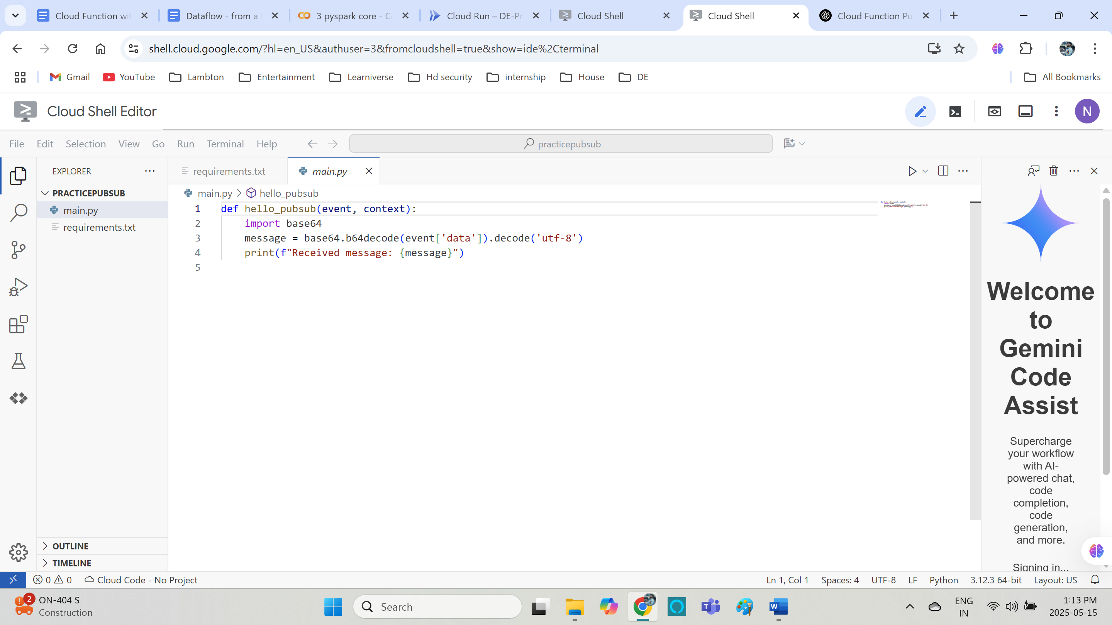

Deployed function

Published message to the topic

Logs

